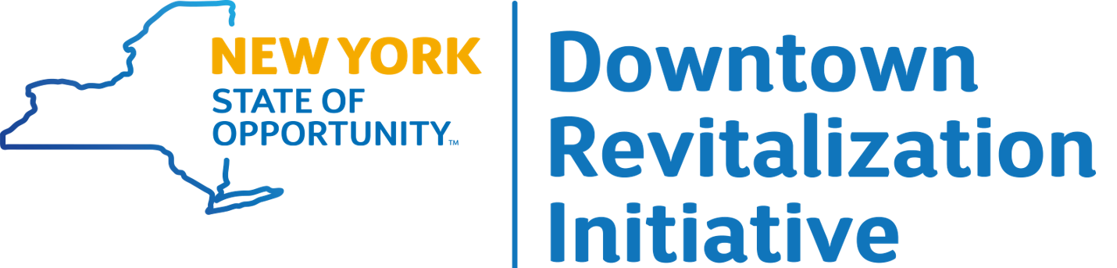

APPLICATION
Applications for the Downtown Revitalization Initiative will be received by the Regional Councils. Applicant responses for each section should be as complete and succinct as possible. Applications should be submitted as Word documents and must be received by the appropriate Regional Council by 4:00 PM on June 1, 2018 at the email address provided at the end of this application. Application guidance is provided in the Downtown Revitalization Initiative Guidebook found on the DRI website at www.ny.gov/dri.
BASIC INFORMATION
Regional Economic Development Council (REDC) Region: Click here to enter text.
Municipality Name: Click here to enter text.
Downtown Name: Click here to enter text.
County Name: Click here to enter text.
Vision for Downtown. Provide a brief statement of the municipality’s vision for downtown revitalization.
Click here to enter text.

JUSTIFICATION
Provide an overview of the downtown area nominated for the DRI program, highlighting the area’s defining characteristics and the reasons for its selection. Explain why the downtown is ready for Downtown Revitalization Initiative (DRI) investment, and how that investment would serve as a catalyst to bring about revitalization.
Click here to enter text.

downtown identification
This section should be filled out with reference to the list of desired attributes for participation in the DRI as set forth in the Downtown Revitalization Initiative Guidebook.
- Boundaries of the proposed DRI area. Detail the boundaries of the targeted neighborhood, keeping in mind that there is no minimum or maximum size, but that the neighborhood should be concentrated and well-defined. Neighborhoods beyond a traditional downtown or central business district are eligible, if they can meet other criteria making them ripe for investment. Attach a map that clearly delineates the area to be included in the downtown revitalization area.
Click here to enter text.
- Description of catchment area. Outline why the proposed DRI area, or its catchment area, is of a size sufficient to support a vibrant, year-round downtown, with consideration of whether there is a sizeable existing or increasing population within easy reach for whom this would be the primary downtown destination.
Click here to enter text.
- Past Investment, future investment potential. Describe how this DRI area will be able to capitalize on prior private and public investment, or catalyze future investments in the neighborhood and its surrounding areas.
Click here to enter text.
- Recent or impending job growth. Describe how recent or impending job growth within or near the DRI area will attract professionals to an active life in the downtown, support redevelopment, and make growth sustainable in the long-term.
Click here to enter text.
- Attractiveness of physical environment. Identify the properties or characteristics that the DRI area possesses that contribute, or could contribute if enhanced, to the attractiveness and livability of the downtown for a diverse population of varying ages, income, gender identity, ability, mobility, and cultural background. Consider, for example, the presence of developable mixed-use spaces, varied housing types at different levels of affordability, walkability and bikeability, healthy and affordable food markets, and public parks and gathering spaces.
Click here to enter text.
- Quality of Life policies. Articulate the policies in place that increase the livability and quality of life of the downtown. Examples include the use of local land banks, modern zoning codes, comprehensive plans, complete streets plan, transit-oriented development, non-discrimination laws, age-friendly policies, and a downtown management structure. If policies achieving this goal are not currently in place, describe the ability of the municipality to create and implement such policies.
Click here to enter text.
- Public Support. Describe the public participation and engagement process conducted to develop the DRI application, and the support of local leaders and stakeholders for pursuing a vision of downtown revitalization. Describe the commitment among local leaders and stakeholders to preparing and implementing a strategic investment plan. Identify an initial local lead for the program that will work with outside experts to convene a DRI Local Planning Committee to oversee the plan.
Click here to enter text.
- Project List to Demonstrate Readiness: Describe opportunities to build on the strengths described above by providing a list of transformative projects that will be ready for implementation with an infusion of DRI funds within the first one to two years (depending on the scope and complexity of the project) and which may leverage DRI funding with private investment or other funds. Such projects could address economic development, transportation, housing, and community development needs. While such projects should have demonstrated public support, it is recognized that projects will ultimately be vetted by the Local Planning Committee and the State. Explain how most projects proposed for DRI funding demonstrate their readiness for implementation.
Click here to enter text.
- Administrative Capacity. Describe the extent of the existing local administrative capacity to manage this initiative, including potential oversight of concurrent contracts once projects are selected for award.
Click here to enter text.
- Other. Provide any other information that informs the nomination of this downtown for a DRI award.
Click here to enter text.

*Don’t forget to attach a map that clearly delineates the proposed DRI Area. (See item 1.)

EMAIL SUBMISSION ADDRESSES
Please submit your application as a Word Document to the Regional Council for your region.
Capital Region NYS-CapitalDist@esd.ny.gov
Central New York NYS-CentralNY@esd.ny.gov
Finger Lakes NYS-FingerLakes@esd.ny.gov
Long Island LIREDC@esd.ny.gov
Mid-Hudson NYS-MidHudson@esd.ny.gov
Mohawk Valley NYS-MohawkVal@esd.ny.gov
New York City NYC-DRI@esd.ny.gov
North Country NYS-NorthCountry@esd.ny.gov
Southern Tier NYS-SouthernTier@esd.ny.gov
Western New York NYS-WNY-REDC@esd.ny.gov

