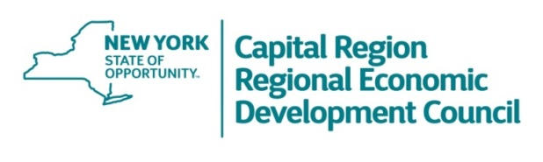

CREDC MEETING AGENDA

9:00 a.m. – 10:30 a.m.

Thursday, August 20, 2020
Via Zoom Conference

Introduction
- Ruth Mahoney, Co-Chair
- Havidán Rodríguez, Co-Chair

Welcome and Opening Remarks
- Lieutenant Governor Kathy Hochul
- Roberta Reardon, Commissioner, NYS Department of Labor

Overview of 2020 Regional Economic Recovery Strategy
- Michael Yevoli, Regional Director, Empire State Development
    - Strategy Outline and Timeline
    - Public Outreach and Data Collection
    - Workgroups and Committees
    - Document Preparation and Status
    - Next Steps

Regional Council Strategy Session
- Full Council
    - Open Discussion regarding Regional Economic Recovery Strategy
    - Next Steps

Adjourn

