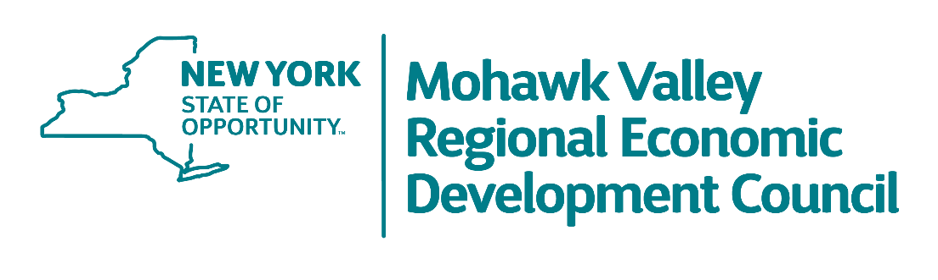
MVREDC MEETING AGENDA

10:00 a.m. – 12:00 a.m.

Wednesday, August 26, 2020
Via Zoom Conference

Introduction
- Larry Gilroy, Co-Chair
- Dr. Marion Terenzio, Co-Chair

Welcome and Opening Remarks
- Lieutenant Governor Kathy Hochul
- Roberta Reardon, Commissioner, NYS Department of Labor

Overview of 2020 Regional Economic Recovery Strategy
- Michael Reese, Regional Director, Empire State Development
- Jennifer Waters, VP Business Development & Communications, Mohawk Valley EDGE
    - Strategy Outline, Timeline, Workgroups & Next Steps

Regional Council Strategy Session
- Full Council
    - Open Discussion regarding Regional Economic Recovery Strategy
    - Next Steps

Adjourn

