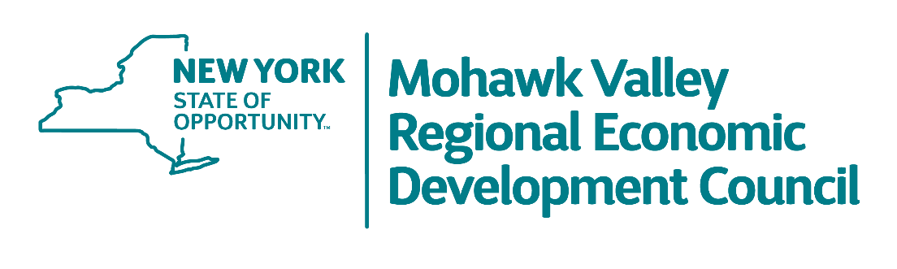
MVREDC PUBLIC MEETING AGENDA

2:00p.m. – 3:00p.m.

Wednesday, March 15th, 2023

Mohawk Valley Community College WH Room 225

- Welcome & Introductions
    - MVREDC Co-Chairs Larry Gilroy & Dr. Marion Terenzio

- MVREDC Updates
    - Allison Madmoune, Regional Director, ESD Mohawk Valley Office

- Scaling Proven PTECH Strategies: Developing Coherent and Cohesive Pathways
    - Tim Thomas, MVCC
    - Chris Hill, Oneida Herkimer BOCES

- Overview of Callahan Management Training Center
    - Mike Frame, MACNY

- Connecting MV SHRM to the work of the MVREDC
    - Theresa Jalowiec, Northland Communications

Adjourn

